
Survey

Do you attend a day support service in Edinburgh?
Or are you the unpaid carer/parent of someone who does?
Edinburgh Voluntary Organisations Council (EVOC) works with charities that support unpaid carers and people with additional support needs or disabilities. They have concerns at changes to transport for people who have a transport service for day support, and also changes for people who have a respite service.
Please can you complete this survey for us. It will help us understand what the impacts are of these changes. We want to work together to improve how services are delivered and so people affected are involved in making these changes.

Please note this survey is about people over 18 or those moving to adult services.

- Do you/the person you care for attend a day support service?

Yes No

- Are you/the person you care for receiving a respite service? (e.g. over night respite, short breaks or respite via day support).

Yes No

- Can you tell us the name of the service you/the person you care for attends?

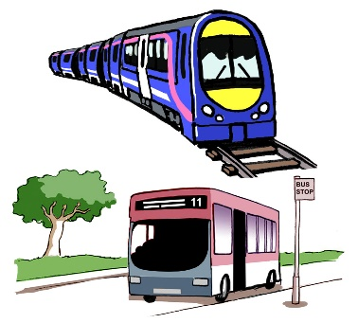
Transport

- Have you or the person you care for used transport provided by the Council/Edinburgh Health and Social Care Partnership (EHSCP) to attend day support or a respite service?

Yes No

- Can you tell us what type of transport service you received before the pandemic to attend a day support service?

Taxi Minibus

Sharing with other people using the service

Support with self travel (like travel training to use public transport)

Providing transport yourself

Other travel arrangements (please tell us about these below )

- Can you tell us what type of transport service you are using just now to attend a day support service?

Taxi Minibus

Sharing with other people using the service

Support with self travel (like travel training to use public transport)

Providing transport yourself

Other travel arrangements (please tell us about these below )

- How many days per week did you have a transport service before the pandemic?

- How many days per week are you having transport service now?

- Can you tell us which organisation provides the transport you use?

City of Edinburgh Council

Pilton Equalities Project (PEP)

South Edinburgh Amenities Group (SEAG)

Handicabs (HCL)

Lothian Community Transport Services (LCTS)

The Dove Centre

Other (please tell us about these below)

- What are the benefits for you and/or the person you care for of having transport? Please tell us in the box below:

- What have been the impacts for you and/or the person you care for of the changes in transport? Please tell us in the box below:

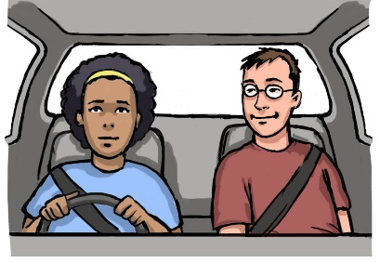

Shared travel arrangements

- Did you share transport before the pandemic?

Yes No

- Have you been asked to share transport now?

Yes No


Financial contributions towards travel costs

- Have you been asked to pay towards the costs of the transport?

Yes No

- Have you been told you must use DLA or PIP mobility for this?

Yes No

Other (please tell us about this below)

- Who contacted you about this and how? Please tell us in the box below:

- Do you have any other comments about this? Please tell us in the box below:



New Assessments

- Have you been told that a new assessment has to be done for services to start again?

Yes No

- Who contacted you about this and how? Please tell us in the box below:

- Do you have any other comments about this? Please tell us in the box below:

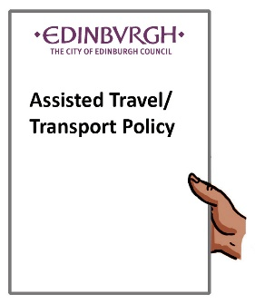

Assisted Travel/Transport Policy

- Are you aware of the current Transport Policy?

Yes No

- Do you have a copy of this policy?

Yes No



Changes in day support since the pandemic

- How many days did you or the person you care for attend the day support service before the pandemic?

- How many days do you attend now?

- Who spoke to you about these changes and how? Please tell us in the box below:



Respite/Short Breaks

- How many days did you or the person you care for attend a respite service before the pandemic?

- How many days do you attend now?

- What respite did you or the person you care for access before the pandemic?

Overnight respite Short breaks

Respite via day support

Other (please tell us about this below)

- Is this respite:

Still available as it was before the pandemic

Reduced

Not available

Other (please tell us about this below)

- Have you been offered/made use of any appropriate alternative respite?

Yes No

Please tell us about this in the box below:

- Who spoke to you about these changes and how? Please tell us in the box below:

- How do you feel about the current transport and respite arrangements for yourself or the person you care for? What is working well? What are the challenges? Please tell us in the box below:

- Can you tell us who has supported you regarding transport and respite arrangements since the start of the pandemic? Please tell us in the box below:

- Do you have a case study to share? If you would like to share a short summary of your experiences with transport and/or respite issues for yourself or the person you care for. Please tell us in the box below:

- Do you have any other comments? Please tell us in the box below:



What happens next?

Once we have all your responses we will produce a report that will share. We want to work to look at how services can develop as we move from the pandemic.
If you would like to be informed and/or involved in further developments in this process, please leave your contact details:

Name:

Address:

Email address:

Phone Number:

Please tick if you would like to be kept up to date and/or involved in further developments:

I would like to be kept up to date with future developments

I would like to be involved in future developments

Thank you for taking the time to complete this survey.

